**From: Ninang Lhen**

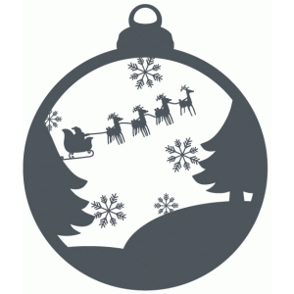

Merry Christmas & Happy New Year! **☺**

**From: Ninong Albert & Ninang Lhen**



Merry Christmas & Happy New Year! **☺**

**From: Ninang Lhen & Ninong Albert**



Merry Christmas & Happy New Year! **☺**